SMART UNIVERSITY RESEARCH COLLABORATION AND
INNOVATION MANAGEMENT PLATFORM
Course Code: | CSA1017 | Course Title: | Software Engineering
CO Assessed: | CO5AT1 | Assessment: | Assessment Tool 1 – Research Paper Review/Literature Survey
Weightage: | 20% | Total Marks: | 25
CO5 Statement: | Evaluate emerging technologies and societal impacts, maintaining and evolving software systems responsibly
Student Name: | S.HarshaVardhan Reddy | Reg. No.: | 192372215
Date: | 22-08-26 | Duration: | 60 minutes

Table of Contents
Abstract 3
1. Introduction 3
1.1 Industry Context and Background 3
1.2 Problem Statement 3
1.3 Objectives of the Study 3
1.4 Scope and Structure of the Report 3
2. Literature Survey Methodology 4
3. Thematic Review of Literature 5
3.1 Research Information Management Systems (RIMS / CRIS) 6
3.2 AI-Based Academic Collaborator Recommendation 7
3.3 AI-Based Funding and Grant Recommendation 9
4. Proposed System Architecture 10
5. Comparative Literature Survey Table 13
6. Limitations and Challenges of Existing Approaches 14
7. Research Gap Analysis 14
8. Future Research Directions 15
9. Conclusion 16
References 16

Abstract
Research management within universities is frequently fragmented across departments, learning management tools, spreadsheets, and disconnected repositories, which makes it difficult to track ongoing projects, publications, patents, funding opportunities, and collaboration potential in a unified manner. This report presents a literature survey conducted in support of the design of a Smart University Research Collaboration and Innovation Management Platform — an integrated digital system intended to digitally manage research projects, track publications and patents, identify collaboration opportunities using artificial intelligence, recommend funding schemes, monitor project milestones, and generate institutional research performance analytics. A systematic, PRISMA-informed search was carried out across IEEE Xplore, ACM Digital Library, Scopus, SpringerLink, ScienceDirect and arXiv, from which ten peer-reviewed studies were selected for in-depth review. The selected literature is organised into three thematic clusters: (i) Research Information Management Systems (RIMS) and Current Research Information Systems (CRIS) used to digitise research administration; (ii) artificial-intelligence-based academic collaborator recommendation approaches built on graph embeddings, graph neural networks and natural language processing; and (iii) AI-based funding and grant recommendation systems that match researcher profiles to funding calls using semantic and learning-to-rank models. Each study is reviewed for its objectives, methodology, datasets or tools, and key findings, followed by a comparative analysis across accuracy, scalability, interoperability and other problem-specific parameters. The survey identifies persistent research gaps — including poor interoperability between institutional systems, limited use of deep-learning-based multi-attribute recommenders in real institutional deployments, weak integration between collaboration and funding recommendation modules, and an absence of unified, explainable, end-to-end platforms tailored to university research ecosystems in developing regions. Based on these gaps, the report proposes a layered system architecture and outlines future research directions for building an intelligent, analytics-driven research collaboration and innovation management platform for universities.

1. Introduction

1.1 Industry Context and Background
Universities today conduct multidisciplinary research that involves faculty members, students, industry partners, and government or private funding agencies working together across departments and, increasingly, across institutions. Effective management of this research activity — tracking projects from proposal to completion, recording publications and patents, connecting researchers with complementary expertise, and matching ongoing work with suitable funding calls — has become central to improving research productivity, institutional rankings, and innovation output. As research volumes grow and collaboration becomes more interdisciplinary and international, universities increasingly require integrated digital platforms rather than the manual, spreadsheet-based, or siloed departmental systems that have traditionally been used to manage this information.
Commercial Research Information Management Systems (RIMS), also referred to as Current Research Information Systems (CRIS), such as Pure, Converis and Symplectic Elements, have emerged over the past decade to address parts of this problem by consolidating researcher profiles, publication metadata, and grant records into a single interface. In parallel, a distinct body of research has developed artificial-intelligence-based recommender systems that suggest potential collaborators and relevant funding opportunities by mining co-authorship networks, citation graphs, and the semantic content of publications and grant announcements. However, these two strands of work — institutional RIMS/CRIS platforms on one hand, and AI-driven collaboration or funding recommenders on the other — have largely developed independently, and few studies examine how they might be unified into a single, intelligent, analytics-generating platform purpose-built for a university research ecosystem.

1.2 Problem Statement
Research management in universities is often fragmented across multiple departments, making it difficult to track projects, funding opportunities, publications, and intellectual property in a coherent, institution-wide manner. An intelligent research management platform is needed that can automate project monitoring, identify collaboration opportunities using artificial intelligence, manage research outputs such as publications and patents, recommend funding schemes tailored to individual researcher profiles, and generate institutional research performance analytics that support strategic decision-making by university leadership.

1.3 Objectives of the Study
This literature survey was conducted with the following objectives, aligned with the broader goals of the proposed platform:
- Review existing approaches to digitally managing university research projects.
- Examine methods used to track publications and patents within institutional systems.
- Analyse artificial-intelligence techniques used to identify research collaboration opportunities.
- Study recommender-system approaches for matching researchers to funding opportunities.
- Understand mechanisms proposed in the literature for monitoring project milestones.
- Investigate approaches to generating institutional research analytics and performance dashboards.
- Identify the limitations, challenges and unresolved research gaps in existing systems.
- Propose future research directions and a candidate system architecture for an integrated platform.

1.4 Scope and Structure of the Report
The remainder of this report is organised as follows. Section 2 describes the literature survey methodology, including the databases searched and the inclusion and exclusion criteria applied. Section 3 presents individual reviews of the ten selected papers, grouped into three thematic clusters. Section 4 proposes a layered system architecture synthesised from the reviewed literature. Section 5 presents a comparative literature survey table. Section 6 discusses the limitations and challenges identified across the existing approaches. Section 7 analyses the research gap. Section 8 proposes future research directions. Section 9 concludes the report, followed by a list of references in IEEE citation style.

2. Literature Survey Methodology
A structured, PRISMA-informed methodology was adopted to identify, screen, and select literature relevant to the assigned problem statement. Search queries combining terms such as "research information management system", "CRIS", "academic collaborator recommendation", "co-authorship prediction", "grant recommender system", and "research analytics dashboard" were run against IEEE Xplore, the ACM Digital Library, Scopus, SpringerLink, ScienceDirect, and arXiv. Records were first screened by title and abstract, duplicates were removed, and the remaining full-text articles were assessed against inclusion criteria requiring that a study be peer-reviewed (journal article, conference paper, or reputable institutional/organisational report), published in English, and directly relevant to research information management, academic collaboration recommendation, or funding/grant recommendation. Studies that were purely commercial marketing material without a described methodology, or that fell outside the research-management domain, were excluded. This process yielded ten core papers that were reviewed in depth for the comparative analysis presented in this report. Figure 1 summarises the selection process.
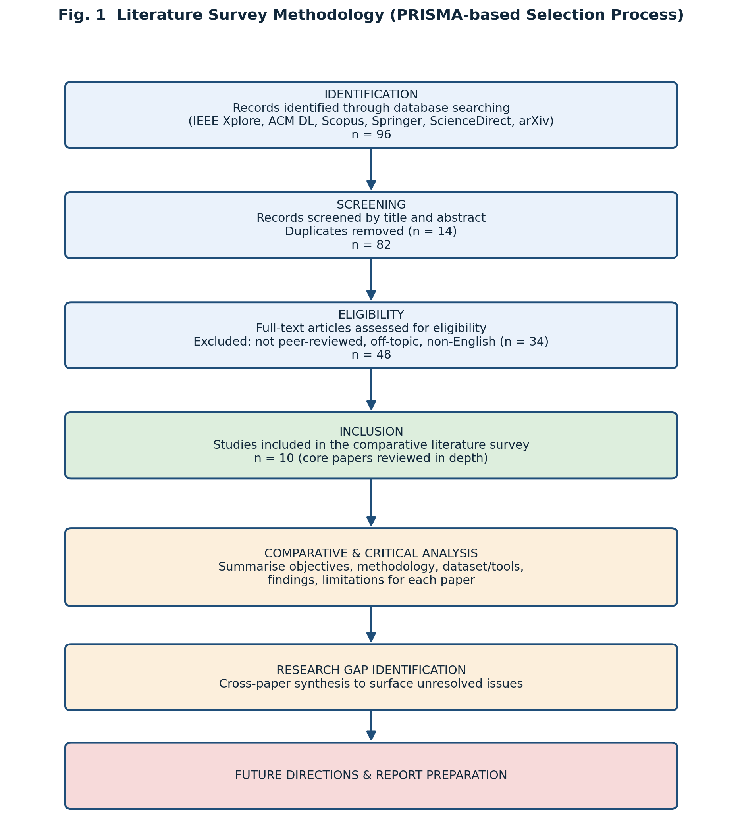
Fig. 1. Literature survey methodology (PRISMA-based selection process).

3. Thematic Review of Literature
The ten selected papers are organised into three thematic clusters that together map onto the core functional requirements of the proposed platform: institutional research information management, AI-based collaborator recommendation, and AI-based funding recommendation.

3.1 Research Information Management Systems (RIMS / CRIS)
This cluster reviews platforms and studies concerned with the institutional-level digitisation of research administration — the consolidation of researcher profiles, publication and patent records, and grant information into a single interoperable system.

Paper 1 — Comparative Evaluation of Commercial RIMS Platforms [1]
Objective: To comparatively evaluate leading commercial Research Information Management Systems used by universities and libraries to manage research information.
Methodology / Technology: A descriptive, feature-based comparative analysis of three widely deployed RIMS/CRIS products — Pure (Elsevier), Converis (Clarivate/Thomson Reuters), and Symplectic Elements — examining their functional modules, data models, and integration capabilities.
Dataset / Tools: Product documentation, vendor case studies, and secondary literature on RIMS adoption at academic institutions and libraries.
Key Findings: The study finds that traditional institutional repositories and digital libraries alone are insufficient to manage detailed faculty and researcher profiles, which motivated the emergence of specialist RIMS products; each platform supports researcher profile management, publication harvesting, and reporting, but differs in configurability, workflow validation, and depth of analytics.
Limitations: The comparison is largely descriptive rather than empirical, does not benchmark system performance or scalability under real institutional data loads, and does not address AI-based recommendation capabilities such as collaborator or funding matching.

Paper 2 — Systematic Review of Research Data Management System Adoption [2]
Objective: To identify, through a systematic literature review, the organisational factors that must be considered when implementing a Research Data Management System (RDMS) in higher-education institutions.
Methodology / Technology: A systematic literature review following an explicit search-and-screening protocol across scientific databases, with studies analysed using an organisational-change framework to classify factors affecting RDMS implementation.
Dataset / Tools: 101 peer-reviewed studies selected from an initial pool of over 1,000 records identified through database searching.
Key Findings: The review shows that successful RDMS implementation depends as much on organisational factors — stakeholder roles, policy alignment, staffing, and training — as on the underlying technology, and that most existing studies focus narrowly on technical aspects while neglecting these organisational dimensions.
Limitations: The review is restricted to English-language publications, which the authors note may exclude relevant regional practices; it also stops short of proposing a concrete technical architecture or evaluating AI-driven functionality.

Paper 3 — Landscape Study of Research Information Management Practice [3]
Objective: To document, through in-depth case studies, how US research universities implement Research Information Management (RIM) in practice, including stakeholders, use cases, and system components.
Methodology / Technology: A qualitative, multi-institution case-study methodology combining interviews and documentary analysis across five research-intensive universities.
Dataset / Tools: Institutional RIM practices and system deployments at five case-study universities, examined against a common analytical framework of RIM use cases and stakeholders.
Key Findings: RIM practice in the United States is found to be highly decentralised, resulting in overlapping systems, duplicated data-entry effort, and inconsistent reporting; the study recommends greater coordination between the library, research office, and IT functions to reduce this fragmentation.
Limitations: As a landscape and case-study report rather than a technical study, it does not propose or evaluate any specific software architecture, algorithm, or AI-based automation for collaboration or funding matching.

3.2 AI-Based Academic Collaborator Recommendation
This cluster reviews artificial-intelligence approaches for identifying and recommending potential research collaborators, ranging from a broad survey of scholarly recommender systems to specific techniques based on network embeddings, context-aware recommendation, and graph neural networks.

Paper 4 — Broad Survey of Scholarly Recommendation Systems [4]
Objective: To comprehensively survey scholarly recommender systems across literature, collaborator, reviewer, conference/journal, dataset, and grant-funding recommendation domains.
Methodology / Technology: A structured literature survey covering 225 publications identified through the ACM Digital Library, DBLP, IEEE Xplore, and Scopus, categorised by recommendation domain and underlying technique (content-based filtering, collaborative filtering, graph-based, and deep-learning approaches).
Dataset / Tools: 225 publications on scholarly recommender systems spanning multiple sub-domains.
Key Findings: Content-based filtering is found to be the most common technique overall, while collaborative filtering is more popular for conference recommenders; deep-learning methods remain comparatively rare across the surveyed publications, and dataset and grant-funding recommenders are notably under-represented relative to literature and collaborator recommenders.
Limitations: Because the survey aggregates a very broad set of recommender types at a high level, it does not provide deep empirical benchmarking of any single technique, and it explicitly identifies grant-funding recommendation as an under-studied area requiring further work.

Paper 5 — Word2Vec and Node2Vec Fusion for Collaborator Recommendation [5]
Objective: To recommend suitable academic collaborators by jointly considering the similarity of researchers' research interests and the topology of their existing collaboration network.
Methodology / Technology: A hybrid framework combining a Word2Vec model to generate embeddings of researchers' research-interest text with a Node2Vec model to learn topological features of the co-authorship network; the two similarity measures are fused using the CombMNZ rank-aggregation method to produce a ranked list of recommended collaborators.
Dataset / Tools: A co-authorship and publication dataset used to construct the collaboration network and research-interest profiles, evaluated using standard recommendation metrics.
Key Findings: Combining textual research-interest similarity with network-topology similarity produces recommendations with better precision, recall, and accuracy than approaches that rely on either signal alone, demonstrating the value of fusing content-based and graph-based signals.
Limitations: The framework is evaluated on a single dataset and does not incorporate researcher attributes beyond text and network topology, such as institutional affiliation, funding history, or patent activity, limiting its applicability to broader research-management use cases.

Paper 6 — Context-Aware Academic Collaborator Recommendation (CACR) [6]
Objective: To recommend high-potential new collaborators for researchers' specific, topic-restricted requests rather than generic collaborator suggestions.
Methodology / Technology: A Context-aware Collaborator Recommendation (CACR) framework composed of a Collaborative Entity Embedding (CEE) network that jointly represents researchers and research topics as vectors, combined with a Hierarchical Factorization Model (HFM) to capture context-specific collaboration tendencies.
Dataset / Tools: A large-scale academic publication and co-authorship dataset used to train and evaluate the embedding and factorization models.
Key Findings: Explicitly modelling the research-topic context of a collaboration request substantially improves the relevance of recommended collaborators compared with prior approaches that ignore topical context, addressing a key limitation of purely network-based recommenders.
Limitations: The model requires a well-specified topic or context as input, which may not always be available in practice, and its computational complexity is higher than simpler network-similarity approaches, raising questions about scalability to institution-wide deployment.

Paper 7 — Graph Neural Network-Based Research Collaborator Recommender [7]
Objective: To develop a collaborator recommendation system capable of capturing complex, evolving dependencies among researchers, including temporal changes in collaboration patterns.
Methodology / Technology: A recommender built on graph neural network architectures — GraphSAGE and a Temporal Graph Network — benchmarked against LightGCN and gradient-boosting-tree baselines.
Dataset / Tools: A large-scale biomedical literature database (MEDLINE), used to construct a dynamic collaboration graph incorporating temporal researcher-researcher interactions.
Key Findings: Graph neural network models, particularly the temporal variant, outperform the non-temporal and gradient-boosting baselines in both internal automatic evaluation and external evaluation through end-user ratings, indicating that modelling the time-evolving nature of collaboration networks meaningfully improves recommendation quality.
Limitations: The evaluation is domain-specific to biomedical research, so generalisability to other disciplines within a diverse university is not established, and the computational cost of temporal graph neural networks may pose scalability challenges for institution-wide, real-time deployment.

3.3 AI-Based Funding and Grant Recommendation
This cluster reviews systems that recommend relevant funding opportunities or grant announcements to researchers by matching researcher profiles, publications, or proposal biosketches against funding-call text using semantic and learning-to-rank techniques.

Paper 8 — GotFunding: Grant Recommendation Based on Scientific Articles [8]
Objective: To recommend relevant grant opportunities to researchers by learning the matching relationship between their publications and historical grant-publication acknowledgement records.
Methodology / Technology: The grant-recommendation problem is formulated as a learning-to-rank task; publication and funding-opportunity text features are used to train a ranking model that scores candidate grants for a given researcher.
Dataset / Tools: Historical records linking scientific publications to the grants that funded them, together with funding-opportunity announcements from funding agencies.
Key Findings: The proposed learning-to-rank recommender achieves high ranking performance (NDCG@1 of approximately 0.945), and the analysis further shows that successful researchers tend to match publications to temporally relevant grants, suggesting that timing is an important, underused signal in funding recommendation.
Limitations: The approach depends on the availability of historical publication-grant acknowledgement data, which may be incomplete or unavailable for early-career researchers or for institutions without well-curated bibliometric records.

Paper 9 — BERT-Based NIH Grant Recommender [9]
Objective: To automatically recommend relevant National Institutes of Health (NIH) grant announcements to researchers based on their publication history, addressing the difficulty of manually searching large grant databases.
Methodology / Technology: A classification-based recommender using Bidirectional Encoder Representations from Transformers (BERT) to capture non-linear semantic relationships between researcher publications and grant announcement text, supplemented with a Dirichlet Process Mixture Model (DPMM) for clustering and a recency-weighting mechanism.
Dataset / Tools: Researcher publications crawled from PubMed and NIH grant opportunities from grants.gov, evaluated using Recall@k, Precision@k, Mean Reciprocal Rank, and ROC-AUC.
Key Findings: The BERT-based recommender outperforms baseline methods such as TF-IDF, BM25, doc2vec and Naïve Bayes classifiers in both internal and external evaluations, demonstrating that transformer-based semantic matching captures researcher-grant relevance more effectively than traditional keyword-based retrieval.
Limitations: The system is domain-specific to NIH biomedical funding and publication data, and the authors note that words used in publications and in funding announcements often differ in specificity, which can still introduce mismatches despite the semantic model.

Paper 10 — Deep Neural Network Matchmaking of Biosketches and Funding RFPs [10]
Objective: To automatically match researcher biosketches with funders' Requests for Proposals (RFPs), reducing the substantial time researchers spend — reportedly up to 200 hours per application — identifying and applying to suitable funding calls.
Methodology / Technology: Four deep-learning architectures using cross-encoding and Siamese-encoding strategies (including BERT combined with a Bi-LSTM layer and back-translation-based data augmentation) are benchmarked against conventional models such as logistic regression and support vector machines.
Dataset / Tools: 12,991 researcher biosketches from a research institution and 2,234 NIH Requests for Proposals spanning 2014 to 2019.
Key Findings: The best-performing deep-learning model, integrating BERT with cross-encoding and a Bi-LSTM layer, substantially outperforms keyword-based search and traditional machine-learning baselines, and the authors argue the approach could be generalised beyond research funding to other matching problems such as job or grant-reviewer matching.
Limitations: The reliance on large, well-curated historical biosketch and RFP datasets for training may limit deployment at smaller institutions with less digitised historical data, and the model's decision process is not fully interpretable to end users.

4. Proposed System Architecture
Synthesising the institutional RIMS/CRIS literature (Section 3.1) with the AI-based collaboration and funding recommendation literature (Sections 3.2 and 3.3) points toward a layered platform architecture that unifies research administration with intelligent recommendation and analytics. Figure 2 presents the proposed architecture for the Smart University Research Collaboration and Innovation Management Platform, structured as five layers: a presentation layer serving faculty, students, industry partners, funding agencies and administrators; an application layer implementing the platform's core functional modules; an artificial-intelligence/machine-learning layer providing collaboration and funding recommendation, and predictive analytics; a centralised data layer; and an external-integration layer connecting to bibliometric databases, ORCID, patent offices, and funding-agency systems.
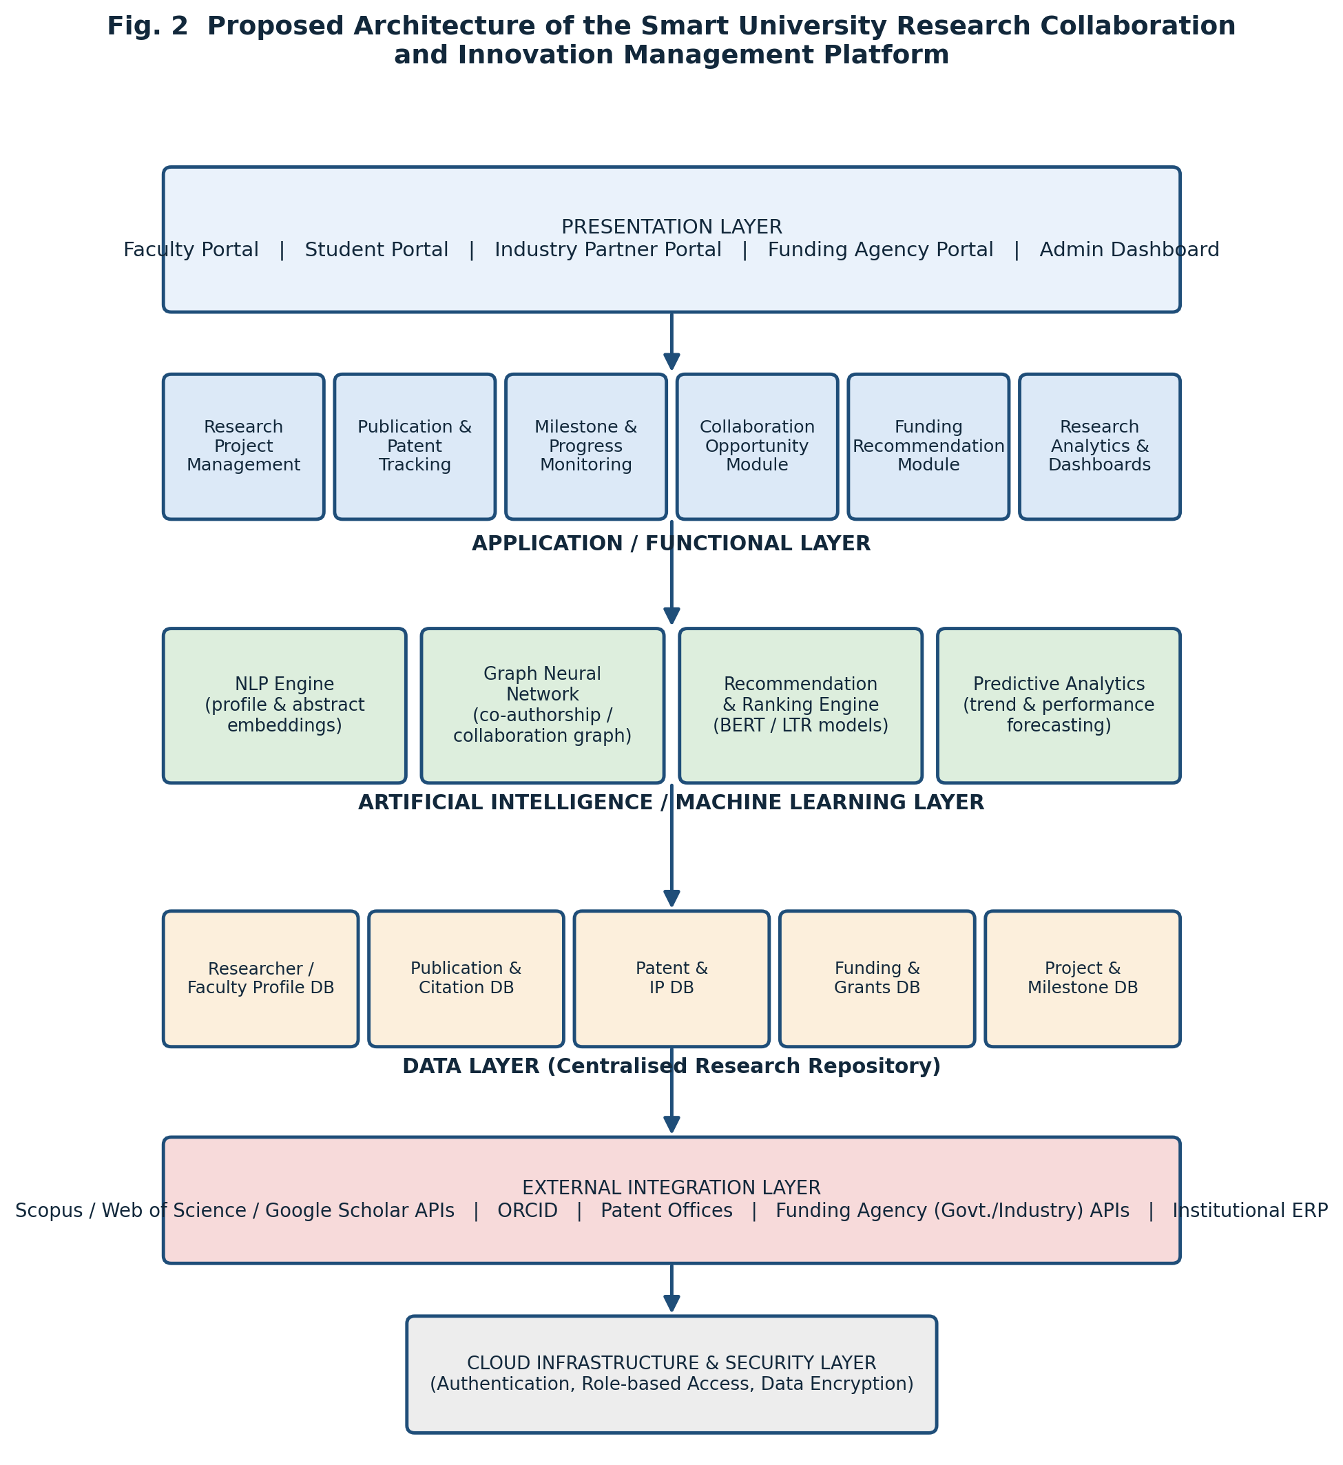
Fig. 2. Proposed architecture of the Smart University Research Collaboration and Innovation Management Platform.
Within the AI/ML layer, the collaboration and funding recommendation modules follow the workflow shown in Figure 3, which is derived directly from the techniques reviewed in Sections 3.2 and 3.3. Researcher profiles, the institutional publication/patent/project repository, and external funding-call data are first processed through a feature-extraction stage that combines NLP-based text embeddings (following the BERT and Word2Vec-based approaches used in Papers 5, 8, 9 and 10) with co-authorship and citation graph construction (following Papers 5, 6 and 7). These features feed two parallel matching engines — a graph-neural-network-based collaborator matching engine and a BERT-based funding matching engine — whose outputs are merged into ranked, explainable recommendations, with a researcher feedback loop used to continually refine future recommendations.
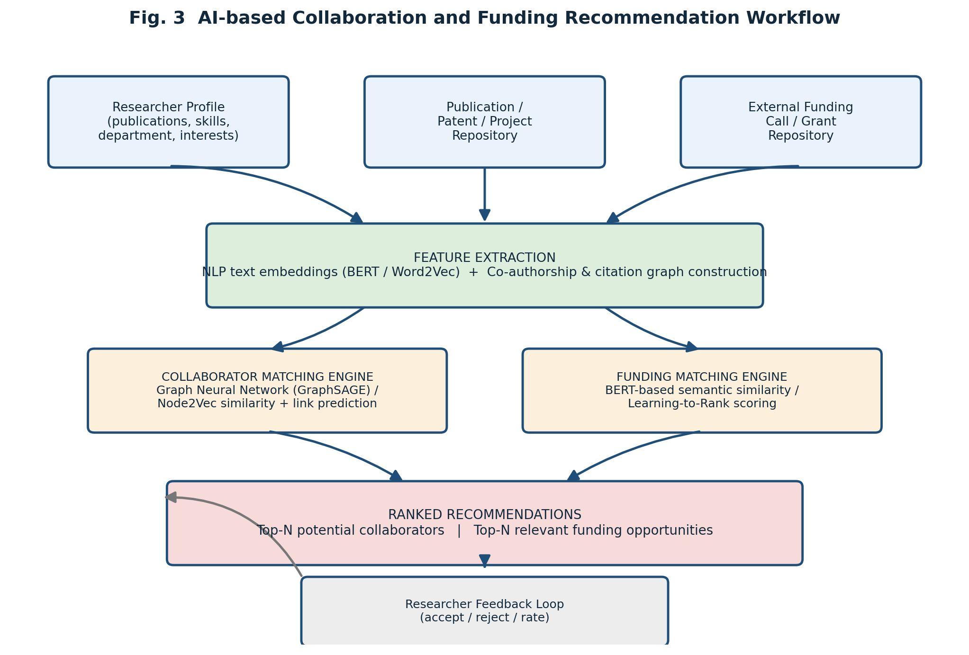
Fig. 3. AI-based collaboration and funding recommendation workflow.

5. Comparative Literature Survey Table
Table 1 presents a consolidated comparative analysis of the ten reviewed papers across author/year, research problem, methodology, dataset/tools, key findings, limitations, and identified research gap.
Author / Year | Research Problem | Methodology | Dataset / Tools | Key Findings | Limitations | Research Gap
Manu et al., 2019 [1] | Comparing commercial RIMS/CRIS platforms for university use | Feature-based comparative analysis (Pure, Converis, Symplectic) | Vendor documentation & case studies | Specialist RIMS outperform generic repositories for researcher profile management | Descriptive only; no performance benchmarking or AI features | Lacks empirical scalability data and AI-based recommendation capability
Donner, 2023 [2] | Organisational factors in RDMS implementation | Systematic literature review (101 studies) | Scientific database search records | Organisational factors matter as much as technology for RDMS success | English-language studies only; no technical architecture proposed | No integration of organisational factors with AI-driven automation
OCLC Research, 2021 [3] | State of RIM practice at US universities | Multi-institution qualitative case studies | Interviews & documents from 5 universities | RIM practice is decentralised, causing duplication and inconsistency | No technical system or algorithm evaluated | No proposed model for unifying decentralised RIM systems
Zhang et al., 2023 [4] | Landscape of scholarly recommender systems | Structured survey of 225 publications | ACM DL, DBLP, IEEE Xplore, Scopus records | Content-based filtering dominant; deep learning & funding recommenders under-studied | High-level aggregation; no deep benchmarking of one technique | Grant-funding and dataset recommenders remain under-researched
Xi et al., 2022 [5] | Collaborator recommendation using interests & network | Word2Vec + Node2Vec fusion (CombMNZ) | Co-authorship & publication dataset | Fusing text and topology similarity improves precision/recall/accuracy | Single dataset; ignores non-text/network attributes (funding, patents) | No multi-attribute (funding/patent-aware) collaborator model
Liu, Xie & Chen, 2018 [6] | Context-restricted collaborator recommendation | CEE embedding + Hierarchical Factorization Model | Large-scale publication/co-authorship data | Modelling topic context improves recommendation relevance | Requires well-specified context; higher computational cost | Scalability of context-aware models to institution-wide use unproven
Zhu & Yaseen, 2022 [7] | Temporal, evolving collaboration recommendation | GraphSAGE & Temporal Graph Network vs. LightGCN/GBT | MEDLINE biomedical database | Temporal GNNs outperform static baselines in automatic & user evaluation | Domain-specific to biomedical field; high computation for real-time use | Cross-disciplinary generalisability of temporal GNNs not established
Zeng & Acuna, 2024 [8] | Matching researchers to relevant grants | Learning-to-rank on publication–grant history | Historical publication–grant acknowledgement records | High ranking accuracy (NDCG@1 ≈ 0.945); timing strongly affects match quality | Depends on historical acknowledgement data; weak for early-career researchers | No mechanism for researchers lacking funding history
Zhu et al., 2023 [9] | Recommending NIH grant announcements | BERT classifier + DPMM clustering + recency weighting | PubMed publications & grants.gov NIH data | BERT-based model outperforms TF-IDF, BM25, doc2vec, Naïve Bayes baselines | Domain-specific to NIH/biomedical funding; vocabulary mismatch persists | Limited cross-domain (non-biomedical) funding recommendation research
Han et al., 2024 [10] | Matching biosketches to funder RFPs | Deep neural networks (BERT + Bi-LSTM, cross/Siamese encoding) | 12,991 biosketches & 2,234 NIH RFPs (2014–2019) | Deep models greatly outperform keyword search and classical ML baselines | Needs large curated datasets; limited interpretability of decisions | Lack of explainable, institution-scale funding-matching systems

6. Limitations and Challenges of Existing Approaches
Synthesising the ten reviewed studies reveals several recurring limitations and challenges that cut across the RIMS/CRIS, collaboration-recommendation, and funding-recommendation literature:
- Fragmentation and poor interoperability: institutional RIMS/CRIS platforms and AI-based recommender systems have largely been studied and built in isolation, so a researcher's profile, collaboration network, and funding history are rarely available to a single recommendation engine [1]–[3].
- Organisational, not only technical, barriers: successful adoption of research information systems depends heavily on stakeholder coordination, policy alignment, and staffing, factors that purely technical studies tend to under-address [2], [3].
- Domain and dataset specificity: several of the strongest-performing AI recommenders were developed and evaluated on biomedical data (MEDLINE, PubMed, NIH grants), leaving their effectiveness in multidisciplinary university settings, including humanities and social sciences, largely untested [7], [9].
- Limited use of multi-attribute signals: many collaborator-recommendation models rely primarily on co-authorship topology and text similarity, without incorporating institutional affiliation, patent activity, funding history, or milestone/project status [5], [6].
- Cold-start and historical-data dependence: funding recommenders that rely on historical publication–grant acknowledgement records perform poorly for early-career researchers or institutions with limited digitised bibliometric history [8].
- Computational cost and scalability: temporal graph neural networks and cross-encoding deep-learning matchmaking models achieve strong accuracy but carry a high computational cost that raises open questions about real-time, institution-wide deployment [7], [10].
- Limited interpretability: deep-learning-based recommenders, while accurate, often provide limited explanation for why a given collaborator or funding opportunity was recommended, which can reduce researcher trust and adoption [9], [10].
- Under-researched funding and dataset recommendation: broad surveys confirm that, relative to literature and collaborator recommendation, grant-funding and dataset recommendation remain comparatively under-studied areas of scholarly recommender-system research [4].

7. Research Gap Analysis
Cross-referencing the limitations identified in Section 6 against the objectives of the assigned problem statement surfaces the following unresolved research gaps relevant to a Smart University Research Collaboration and Innovation Management Platform:
- Absence of a unified platform: no reviewed study proposes or evaluates a single, integrated system that combines institutional research-project management, publication/patent tracking, AI-based collaborator recommendation, and AI-based funding recommendation within one architecture; the literature instead treats these as separate problems [1]–[10].
- Weak cross-institution and cross-discipline generalisability: most AI recommendation techniques are validated on a single discipline or a single institution's data (e.g., biomedical MEDLINE/NIH data), leaving open how well these techniques generalise across the full range of departments in a typical university [7], [9], [10].
- Limited incorporation of milestone and project-monitoring data into recommendation: none of the collaboration or funding recommenders reviewed make use of ongoing project-milestone status as an input signal, despite milestone monitoring being a core objective of institutional research management [1]–[10].
- Underdeveloped explainability for institutional adoption: while deep-learning models outperform classical baselines in accuracy, the reviewed literature gives limited attention to producing human-interpretable justifications suitable for research-office staff and university leadership, which is important for institutional trust and adoption [9], [10].
- Sparse research on institutional-level research analytics: while individual RIMS/CRIS platforms provide reporting features, the literature offers little empirical study of how AI-generated collaboration and funding recommendations could feed into institution-wide research performance analytics and ranking-related dashboards.
- Cold-start handling for early-career researchers and smaller institutions: existing funding recommenders depend on historical acknowledgement or biosketch data that early-career researchers and less digitised institutions may not have, and no reviewed study directly addresses this cold-start problem in the funding-recommendation context [8], [10].

8. Future Research Directions
Building on the identified research gaps, the following future research directions are proposed:
- Design and evaluate a unified platform architecture, such as the layered architecture proposed in Section 4, that integrates project management, publication/patent tracking, milestone monitoring, and AI-based collaboration and funding recommendation within a single system rather than as separate tools.
- Extend graph-neural-network and transformer-based recommendation techniques (Papers 5–7, 9, 10) beyond biomedical domains to multidisciplinary university datasets, and empirically evaluate their generalisability across departments such as engineering, humanities, and social sciences.
- Investigate multi-attribute recommendation models that combine co-authorship and citation graphs with institutional affiliation, patent records, project-milestone status, and funding history as joint input signals, addressing the single-signal limitation identified in Section 6.
- Develop explainable-AI techniques for collaboration and funding recommendations — for example, attention-based or rule-augmented explanations — so that research-office administrators and researchers can understand and trust automatically generated recommendations.
- Design cold-start strategies for early-career researchers and smaller or less digitised institutions, such as onboarding-survey-based profiling or transfer learning from larger institutional datasets, to reduce dependence on extensive historical publication or grant records.
- Empirically study how AI-generated collaboration and funding recommendations, combined with milestone-monitoring data, can feed institutional research-performance analytics dashboards to support strategic decisions and improve institutional research rankings.
- Evaluate the real-time computational scalability of temporal graph neural networks and cross-encoding transformer models under the concurrent-user loads typical of an institution-wide platform, to determine practical deployment feasibility.

9. Conclusion
This literature survey reviewed ten peer-reviewed studies spanning institutional Research Information Management Systems, AI-based academic collaborator recommendation, and AI-based funding recommendation, in support of the design of a Smart University Research Collaboration and Innovation Management Platform. The review shows that while mature commercial RIMS/CRIS platforms and increasingly sophisticated AI recommender systems both exist, they have developed largely independently, leaving a clear gap for an integrated platform that unifies research-project management, publication and patent tracking, milestone monitoring, AI-driven collaboration and funding recommendation, and institutional research analytics within a single, interoperable, explainable system. The comparative analysis and research-gap discussion presented in this report, together with the proposed layered architecture, provide a foundation for future work aimed at improving research collaboration, increasing publication and innovation output, and strengthening institutional research performance in line with the objectives outlined in the assigned problem statement.

References
- T. R. Manu, K. Shaan, and S. Kumar, "Research information management systems: A comparative study," in Research Data Access and Management in Modern Libraries, R. K. Bhardwaj and P. Banks, Eds. Hershey, PA, USA: IGI Global, 2019.
- E. K. Donner, "Research data management systems and the organization of universities and research institutes: A systematic literature review," Journal of Librarianship and Information Science, vol. 55, no. 2, pp. 261–281, 2023.
- OCLC Research, Research Information Management in the United States, Parts One and Two, OCLC Research Report. Dublin, OH, USA: OCLC, 2021.
- Z. Zhang et al., "Scholarly recommendation systems: A literature survey," Knowledge and Information Systems, vol. 65, pp. 4433–4478, 2023.
- X. Xi, J. Wei, Y. Guo, and W. Duan, "Academic collaborations: A recommender framework spanning research interests and network topology," Scientometrics, vol. 127, no. 11, pp. 6787–6808, 2022.
- Z. Liu, X. Xie, and L. Chen, "Context-aware academic collaborator recommendation," in Proc. 24th ACM SIGKDD Int. Conf. Knowledge Discovery & Data Mining (KDD), 2018, pp. 1870–1879.
- J. Zhu and A. Yaseen, "A recommender for research collaborators using graph neural networks," Frontiers in Artificial Intelligence, vol. 5, art. 881704, 2022.
- T. Zeng and D. E. Acuna, "GotFunding: A grant recommendation system based on scientific articles," arXiv preprint arXiv:2405.12840, 2024.
- J. Zhu, B. G. Patra, H. Wu, and A. Yaseen, "A novel NIH research grant recommender using BERT," PLOS ONE, vol. 18, no. 1, art. e0278636, 2023.
- S. Han, R. Richie, L. Shi, and F. Tsui, "Automated matchmaking of researcher biosketches and funder requests for proposals using deep neural networks," IEEE Access, vol. 12, pp. 98096–98106, 2024.

